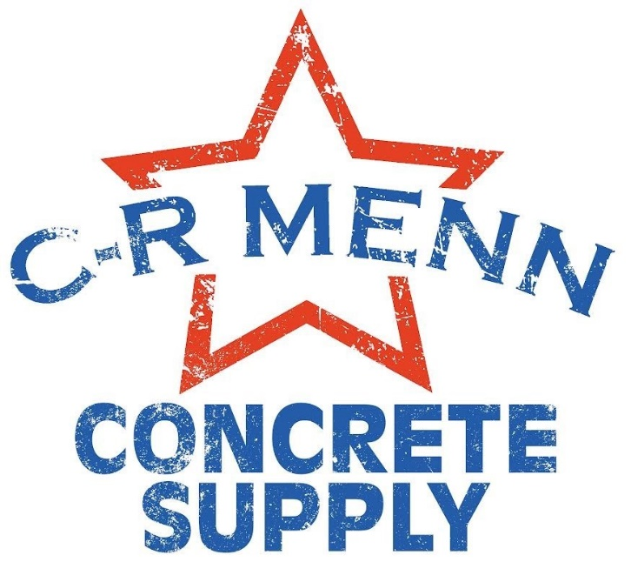
Price Sheet
Effective 1-1-2024
(ALL PRICES SUBJECT TO CHANGE WITHOUT NOTICE)

Mix Identification | Price Per Cubic Yard
Limestone
L10 - 6.5 | $166
L10 - 7 | $169
L10 - 7.5 | $172
L30 - 6.5 | $170
L30 - 7 | $176
L30 - 8 | $185
47B
SG - 6 | $159
SG - 6.5 | $164
SG - 7 | $169
SG - 8 | $175
Flowable Fill | $138
Shotcrete | $195

Minimum Load Charges/ Delivery Fee
For loads less than 10 cubic yards, a Delivery Fee (per order) will be charged as follows:
3 yards or less | $150
3 yards to 5 yards | $100
5 yards to 8 yards | $75
8 yards to 9.75 yards | $50

Concrete Fibers (1lb per cubic yard): There will be an added cost of $11.00 per cubic yard.
Winter Service Fee: For concrete delivered November 15th through March 31st, there will be $5.00 per cubic yard added to the price listed.
Hot Water: For concrete delivered November 15th through March 31st, there will be $5.00 per cubic yard added to the price listed.
Holding Charges: We reserve the right to charge $160.00 per hour for holding trucks on the jobsite in excess of 60 minutes, regardless of load size. Holding time will be assessed in 15-minute increments, at a rate of $40.00.
Fuel Surcharge: We reserve the right to add a fuel surcharge of $35.00 per truck delivered when fuel exceeds $3.00 per gallon.
Delivery Surcharge: Deliveries beyond 15-mile radius of Plant are subject to mileage charges of $5/mile

Non-Chloride Accelerator:
18 oz/100# | 1.0% | $7.25 per yard
27 oz/100# | 1.5% | $11.00 per yard
36 oz/100# | 2.0% | $14.50 per yard

**Prices stated on this sheet are only valid if paid within 10 days of receiving the order. All orders paid for after 10 days will have a 10% price increase. Prices stated do NOT include sale tax**

24/7 Delivery Available
*Upon Request*
*Contractor Pricing Available Upon Completion/Approval of Credit Application*

